Action inquiry and the Global Leadership Profile

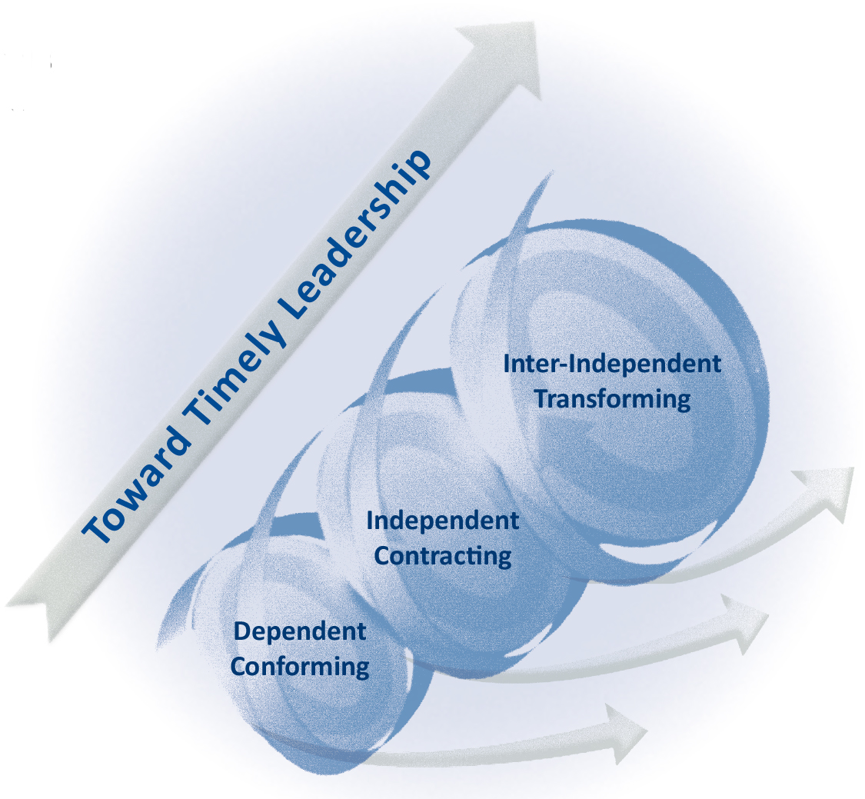
For the second time in Spain a 3 day workshop for business leaders, consultants, coaches, researchers, and sustainability practitioners who wish to further their personal development and learn about the power and practice of Collaborative Developmental Action Inquiry – the only approach statistically confirmed as reliably generating both personal and organizational transformation.

All workshop participants take the Global Leadership Profile (GLP) and receive feedback on their center-of-gravity, emergent, and fallback leadership action-logics. Those who wish can become authorized to use and debrief the GLP with their clients.

Offered by Elaine Herdman-Barker and Verónica Menduiña, with Pablo Tovar joining us on one of the days, Action Inquiry is the only program that comprehensively blends the what, why and how of transformational leadership development, including:
“While we can’t predict
the future, we can
transform ourselves and
our organizations
to effectively meet it”
– Bill Torbert
- the theory of Collaborative Developmental Action Inquiry (CDAI)
- the assessment of leaders’ predominant action-logics (either using the GLP or in-action diagnoses), and
- the ongoing practice of Action Inquiry at the personal, team, and organizational scales

The workshop experience
At our workshops you will never be passively hearing somebody telling you how to do it right. Rather, you will be exercising active listening and leadership, moving among peers in a community of inquiry, receiving direct feedback about your leadership impact, thereby learning together practical ways to help yourself and others:

- Assess current leadership actions-logics – the center-of-gravity, emergent and fallback perspective that guide action and influence results
- Become conscious of and shift action/ mental/ emotional habits that are limiting effectiveness
- Exercise personal power with greater flexibility and mutuality to generate personal and organizational transformation
- Develop collaborative practices that increase mindful, relational, and cultural intelligence in the wider organization
- Build capacity to lead from the inside out, confidently responding to the deepest calls of our human nature and other natural world that hold us

Facilitation Team
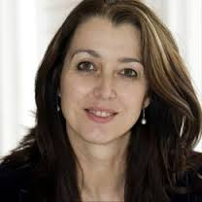
Elaine Herdman-Barker – President of GLA and co-creator of the Global Leadership Profile, leading authority on assessing and supporting change in leadership action-logics. Elaine is a Lecturer at DeBaak Management Centrum in the Netherlands and leads the Action Inquiry and Certification Workshops as well as Leadership Master classes across Europe, North Africa, and America. She consults across multiple sectors, with a worldwide coaching practice, specializing in the development of high potential leaders and senior executives.
Verónica Menduiña – Family therapist since 1999, and coach and business consultant on leadership development and organisational transformation since 2006. She has a wide expertise in dealing with organisational, family and personal conflicts from a systemic approach. As a senior trainer member of the Bert Hellinger Spanish Association, she teaches the Systemic Constellation method. She has published some articles in “The Knowing Field”, an International magazine concerning the Systemic Constellation Work. As an expert in leadership development and organisational transformation she has been certified in the Developmental approach with Bill Torbert and Robert Kegan. She works closely with Bill Torbert being the representative in Spanish of the Action Inquiry Associates LLC and GLP.
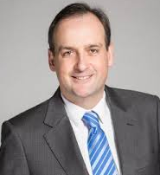
Pablo Tovar – Executive coach, speaker and expert in leadership development and organisational transformation. Managing Partner in AddVenture and Fellow in Oxford Leadership. With 25+ experience in people management he has recently been involved in projects of leadership development and organisational transformation in companies like BASF, Ferrovial, Leroy Merlin, L’Oréal, Novartis, Repsol, Sanofi, Santander, Telefónica… He holds a degree in Psychology, a Master degree in HR Management and has fully completed several business administration and leadership development programmes at IESE, ESADE and Harvard University.

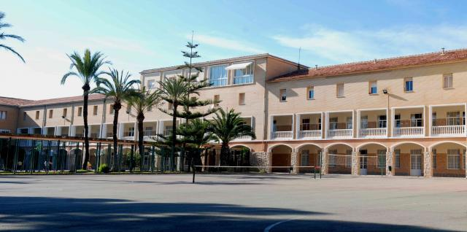
Practical Details
21, 22, 23 June 2018

Alicante, Spain

Thursday 21st, 11:00 – 18:00

Friday 22nd, 9:00 – 18:00

Saturday 23rd, 9:00 – 17:00

Venue:

Residencia Salesiana, Calle Bernat Metge, 8, El Campello, 03560

Investment: 3.250€ for corporate clients. 2.750€ for independent coaches, consultants, faculty members. Fee reduced 300€ if you commit prior to April 1st, 2018. Lodging and meals are included. It is also included in the workshop the GLP test and report that will need to be completed before 4th May 2018. Add 500€ for post-workshop coaching if you are seeking authorization as a GLP debriefer. Workshop limited to 20 participants.
Pre-requisite to workshop Read Action Inquiry: The Secret of Timely and Transforming Leadership by Bill Torbert and Associates prior to workshop (available at Amazon). Additional reading including Herdman-Barker and Wallis’ latest article on transformational development will be provided upon registration.
If interested, please contact Verónica Menduiña at veronica@veronicamenduina.com or phone (+34) 665360663

